Contact Name ___________________________________ Organisation __________________________________________

Contact Tel _________________________________ Email _______________________________________________

Delivery Address_____________________________________________________________________________________________

Kidsafe Information Resources | Language | Format | Cost  per unit | Quantity Required
Ages and Stages Fact Sheets  Ages and Stages Birth-9 months Factsheet  Ages and Stages 9-18 months Factsheet  Ages and Stages 18 months- 3.5 yrs Factsheet  Ages and Stages 3.5 – 5 yrs Factsheet | English | A4 flyer – ONLINE DOWNLOAD ONLY | Nil | NA
All Ages and Stages Factsheets are available to download from Kidsafe Victoria website in the following languages: Arabic; Chinese; Croatian; English; Macedonian; Serbian; Somali; Turkish; Vietnamese - https://www.kidsafevic.com.au/resources/ages-and-stages
Safety for our Little Fellas - Aboriginal Child Injury Prevention Kit | English (largely image based resources) | The ‘Safety for Our Little Fellas’ kit is designed to provide organisations and services with a tool to effectively engage Aboriginal parents and carers in learning and discussion about child injury prevention. The Kit contains an A3 sized presentation flipchart, A3 posters and A4 fact sheets. | Nil
Child Restraint Height Chart | English | 145cm height chart containing handy child restraint hints and tips. | Nil
Emergency Numbers Fridge Magnet | English | Fridge magnets containing important emergency contact phone numbers. | Nil
‘Safe Barriers Save Lives’ campaign flyer | English | DL flyer with mini checklist of things to check to assist in keeping your pool/spa area safe. | Nil
The Battery Controlled Campaign poster | English | A3 poster with information on the dangers posed by button batteries. | Nil
The Battery Controlled flyer | English | DL flyer which provides information on the dangers posed by button batteries. | Nil
‘Find a Fitter’ flyer | English | DL flyer with links to ‘Find a Fitter’, an online listing of child restraint fitting stations in Victoria. | Nil
National Child Restraint Guidelines flyer | English | DL flyer which provides a guide for parents and carers to assist them in keeping their children as safe as possible when travelling in motor vehicles. | Nil
Kidsafe Victoria flyer | English | DL flyer which outlines Kidsafe Victoria’s services. | Nil
Burns and Scalds flyer | English | DL flyer which provides parents with information on burns and scalds including: common causes, prevention tips and first aid procedures . | Nil
Do Not Leave Children in Cars’ Traffic Sign | English | Aluminium sign, 30mmx 45mm; used in car parks to remind parents of the dangers of leaving young children unattended in cars. | $70.00 each or $60 each for bulk orders of 10 or more

Please note a postage charge of $15 will be charged per order (orders of the emergency numbers fridge magnets, do not leave children in cars traffic signs and large quantities of resources may incur a higher postage fee due to their weight/number of packages that are required to be sent).
Please send your completed order form to: Kidsafe Victoria Inc, C/o Monash Children’s Hospital
Locked Bag 29, Clayton South, Victoria, Australia 3169
Tel. 03) 9036 2306 Email info@kidsafevic.com.au
Cheques or money orders to be made out to Kidsafe Victoria.
‘Do Not Leave Children in Cars’ Traffic Signs - Order Form
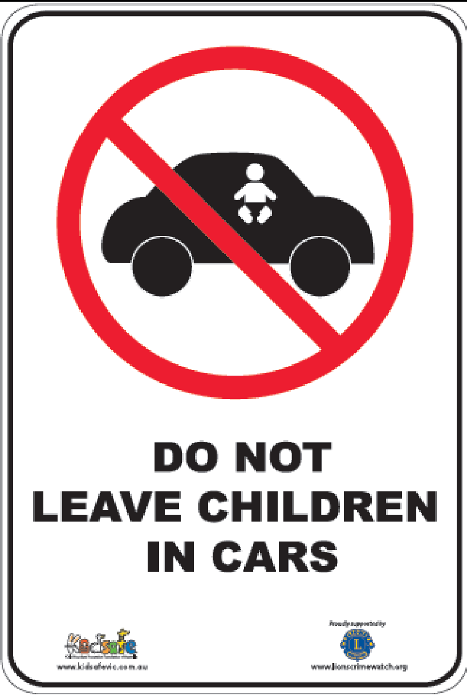
Help Kidsafe prevent children being left in cars.
By installing this traffic sign in your car parking area, your organisation can help raise community awareness regarding the dangers of leaving children unattended in cars.
The signs are ideally suited for Local Government car parks at shops, parks or gardens and also applicable to designated car parks of shopping centres, hotels/entertainment venues, business premises, schools or childcare centres etc.
Available for $70.00 each, or $60.00 each for orders of 10 or more (plus postage).
Proceeds go directly to Kidsafe VIC Inc to continue its work to prevent child injury and related deaths and disability.

Contact Name

Organisation

Address

Suburb Postcode

Contact Tel

Email

Quantity Required

Payment to be by (please tick)
  - Direct EFT to Kidsafe VIC Inc, Bank Australia BSB: 313 140 ACC: 1208 8805
  - Cheque attached, made out to Kidsafe VIC Inc.
  - Kidsafe to send tax invoice.

Delivery Address (if different from above)

Suburb Postcode

Please send your completed order form to:
Kidsafe Victoria Inc
C/o Monash Children’s Hospital
Locked Bag 29, Clayton South
Victoria, Australia 3169
Tel. 03) 9036 2306 Email info@kidsafevic.com.au

